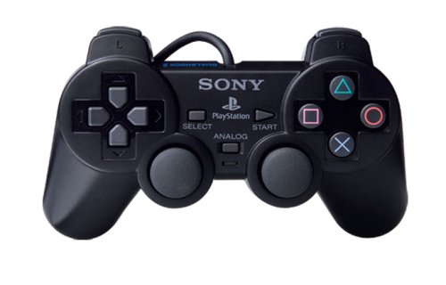There are several improvements that could be made to the interface of the PlayStation 2 controller. One such improvement that could be made is better placement of the analogue sticks. The image below shows the standard PS2 controller, the analogue sticks are placed in very ineffective locations especially compared to other controllers such as the Xbox 360 controller. They are placed where the thumbs would naturally go to rest however this not actually good placement. On the Xbox 360 controller the left stick is placed where the directional buttons are placed on the PS2 controller. This allows for easier use as the left stick is normally used for movement in games and is used more than the directional buttons or the other stick. Having the sticks in two distinct locations allows the user to more easily control movement in games.

Other improvements to the sticks could be making them indented to provide better grip for the user. The sticks on the PS2 controller are rounded at the top and don’t provide much grip especially when fast reflexes are required for example in a first-person shooter game.

Other improvements would consider where the interaction is taking place so that they match the users’ activities and needs. These sorts of improvements would involve the length of the cable that connects the controller to the console. When the device was released the length of the cable was not very long and as such prevented the user from sitting too far away. This is a problem as the console was intended for use in a living room or other similar rooms where the user would be sitting in a chair not directly in front of the television where a longer cable would be needed.

Overall the controller does have good usability as it is easy to use and is effective and does provide an enjoyable experience. However, the controller does seem to be designed by engineers for the most part and users don’t seem to have been involved much in the design process. This is because the controller does have a very symmetrical design and while the placement of the buttons and sticks is logical, they could be more effective. Also, the buttons could be more distinct and colourful in order to provide greater usability. Another comparison can be drawn with the Xbox 360 controller where the buttons are bright and colourful as opposed to just having coloured shapes on the buttons.

Another improvement would be the shape and feel of the controller. The PS2 controller felt quite small when held with both hands and didn’t feel sturdy. A way to improve this would be to make the controller bigger and bulkier in order to feel sturdier and fit the hands better, also optional grips could be provided to help fit all hand sizes and improve the overall feel of the controller. Also, the plastic that the controller is made from became difficult to keep hold of after extended periods of use when sweat from the user’s hands would be transferred onto the controller. The image below shows the Xbox 360 controller, the design of this controller incorporates bright and colourful 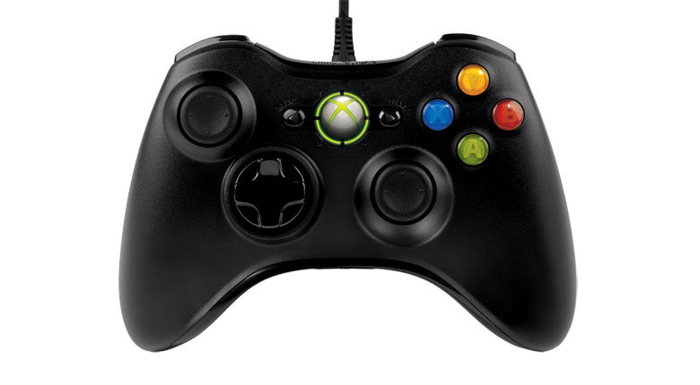buttons as well as a more optimal layout of the controls.

The Xbox 360 controller has a thicker frame which allows for better grip, especially for people with larger hands. This contrasts the PS2 controller which is smaller. On the Xbox 360 controller the directional buttons are used less so therefore they were moved out of the way to allow for better placement of the sticks. The centre button on the Xbox controller lights up as well to show that it is connected and to also indicate which player the controller belonged to, for example the top left part of the circle would be lit up to indicate that it is player one. The PS2 controller had no visual cues to show if it was connected or not.

The PS2 controller does have good utility as the controls are all necessary as none of them could be transferred to being options on a menu displayed on the screen. The controls did have good memorability as they were mostly standard across other controllers as well, for example on both the Xbox and PlayStation controllers the button used to jump in games as placed at the bottom of the control scheme compared to the other buttons. In the case of the PS2 it is the X button and in the case of the Xbox 360 it is the green A button.

In order to make the controls of the X, circle, square and triangle buttons more efficient we could arrange them in a different format as opposed to having them be placed in a circle. An example of this would be the Nintendo GameCube controller.

As seen in the design of the GameCube controller the buttons are placed in a different format with the A button being bigger and central, the B button being made a completely different colour and placed differently, and the X and Y buttons being made different shapes. This provides a more memorable experience for the user as the buttons are placed in different locations and have been made in different shapes thus making them more tactile.

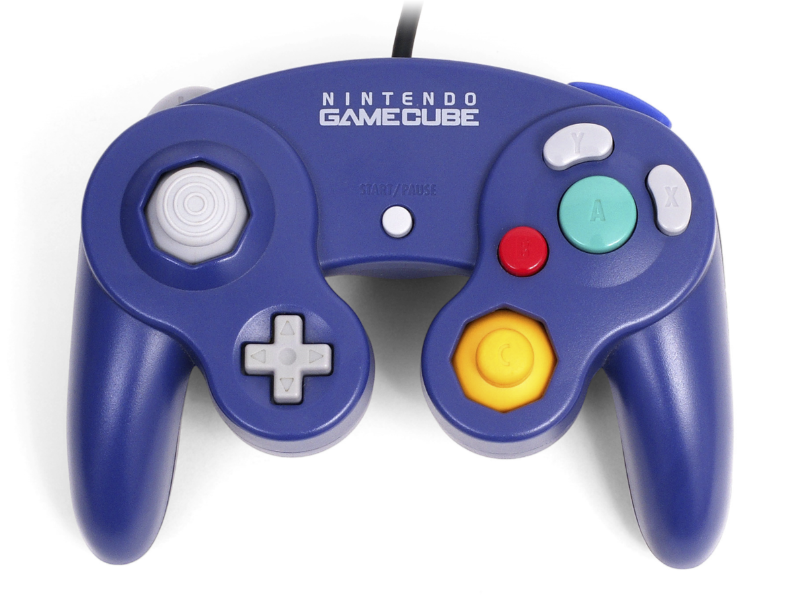The L2 and R2 buttons on the back of the PS2 controller could also be made into triggers rather than solid buttons. This would provide a more tactile feeling as the user gets a different sort of feel pressing a trigger than just a solid button, for example in shooter games the left trigger would be used to aim, and the right trigger would be used to shoot. Also, in racing games the left trigger would be used to brake, and the right trigger would be used to accelerate.

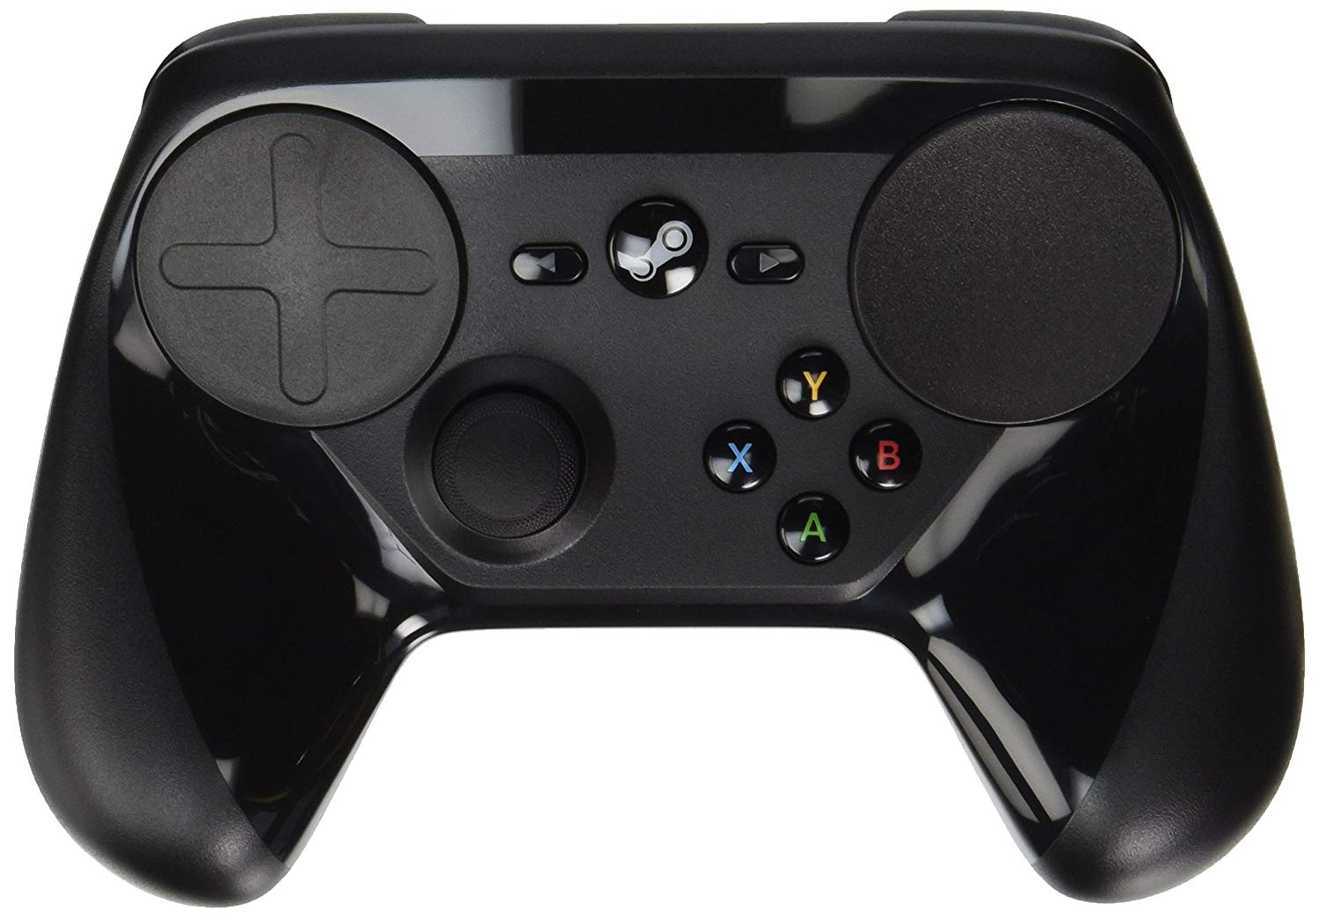The Steam controller is very different to the PS2 controller, one reason being the placement of the sticks. The Steam controller only has the one physical stick and a trackpad on the right of the controller that acts as a sort of stick as well. The grips are inverted on the Steam controller as well as opposed to the PS2 controller, this allows for better handling of the controller.

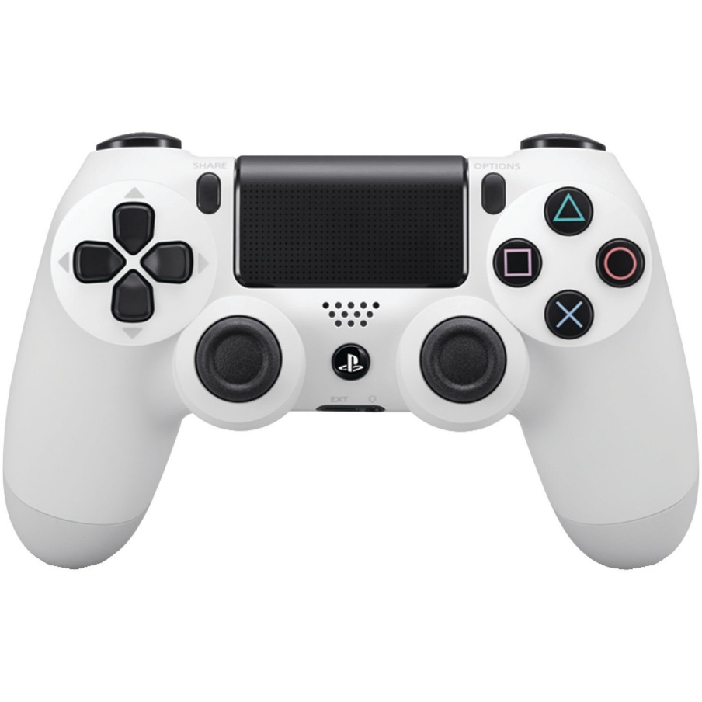The PS4 controller is a newer iteration of the classic PS2 controller. With the advancement of technology, it has allowed for a touchpad at the top of the controller. The PS4 controller is also wireless which means there is no wire to be tripped over and the user can sit anywhere without having to worry about the range of the cable. The thumb sticks also have better grips. There is also a speaker built into the controller to allow for more immersive experience than what was available on the PS2.